“This Is What We Said”
Australian Aboriginal people give their views on the Northern Territory Intervention
At the 2010 Wentworth Lecture, The Hon. Michael Kirby AC CMG said of the book “I commend to those who have not seen it, ...“This Is What We Said”,… because these are words that we should hear, that our Parliament should hear, that our leaders should hear.”
‘This Is What We Said’ was launched in February 2010. Using pictures and quotations taken from footage of actual consultations at Bagot, Ampilatwatja, Utopia and Yirrkala in 2009, plus quotes from other well known Australians and UN representatives, this book provides a graphic account of true feelings of many Aboriginal people in the Northern Territory about the Intervention. The legislation passed by Parliament in June paid scant attention to the views expressed by many Aboriginal people during the consultations process.
The hard back book is available at A$15 + A$2 packaging and post, per copy, within Australia. For orders larger than 4, packaging & postage is free, but please note it is best to order in multiples of 9. e.g. 9,18, 27 etc.
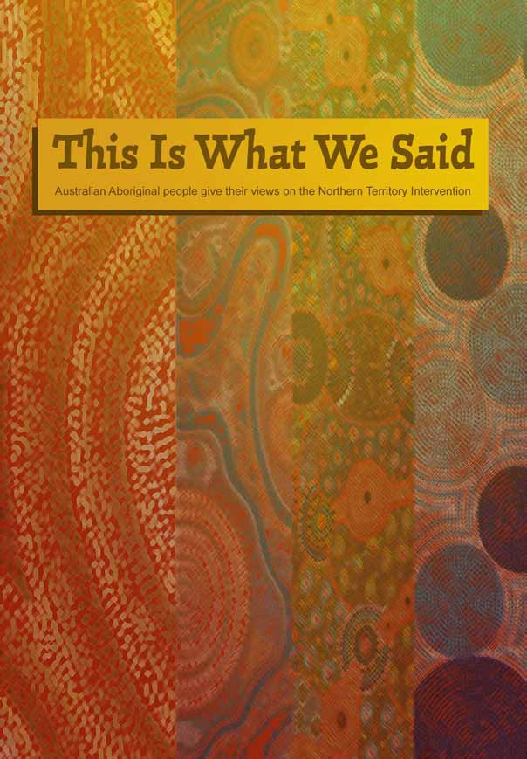
To purchase, print and fill in the order form and mail to:
Michele Harris, concerned Australians, PO Box 281, East Melbourne, Victoria 8002
AND
- Attach your cheque (made payable to Michele. A. Harris) for the total amount payable and send with order form
OR
- make a payment directly into the account below, providing your full name as a reference.
Account name Michele Harris
BSB 733 031
Account number 578 268
For more information or for purchase outside Australia please contact harrisme@bigpond.com

Purchase Order Form for “This Is What We Said”
Your details (please print)
Name
Organisation (if applicable)
Address Street Suburb
State Postcode Phone number
Email
Price per copy - A$15 + A$2 packaging and postage (Packaging & postage is free for orders of 4 or more copies)
Number of copies
Total payment A$ Attach cheque made payable to Michele. A. Harris

