MEDIA RELEASE ‘concerned Australians’ – 15 August
NT Aboriginal Elders Take their Message to the Committee on the Elimination of All Forms of Racial Discrimination in Geneva
Rev Dr Djiniyini Gondarra OAM and Rosalie Kunoth-Monks are on their way home from Geneva where they had been attending the 77th Session of the Committee for Elimination of All Forms of Racial Discrimination. According to Dr. Djiniyini this was an important meeting for both of them. He said, “We were able to present evidence first hand. We were able to close the information gap”.
He continued, “We were able to speak from the soul. The environment in which we were speaking was one focused solely on human rights; it was not intruded upon by politics. We were able to reach the heights in dialogue and understanding that we hadn’t expected.”
Rosalie spoke of the importance of the visit to the UN. “It is the land that holds us together and following the second invasion of the 2007 Intervention, we are hurting, we are suffering. I went to the UN to relieve my pain by being able to present the true facts of what is happening in the remote parts of our country. I had to find a platform where it could be told.”
The meeting was attended by the Australian Government delegation led by HE Ambassador Peter Woolcott and representatives from a number of different government departments. (FAHCSIA, DEEWR, DOHA, DIAC, AGD)
The NGO Meeting with the Members of the CERD Committee commenced with a traditional welcome ceremony by Dr. Djiniyini. The NGO team included the Australian Racial Discrimination Commissioner, Graeme Innes, Les Malezer from FAIRA and representatives from the National Association of Community Legal Services, Australia International and the National Native Title Council. Members of the Committee were generous in their welcome to Rosalie and Djiniyini.
On 9th August Rosalie and Djiniyini joined with Rodney Dillon from Amnesty International and Brian Wyatt from the National Native Title Council. They each spoke at a presentation for the International Day of the World’s Indigenous Leaders.
The Race Discrimination Commissioner, Graeme Innes, in his presentation said, “Rosie and Djiniyini, you are descendants of ancient peoples, the world’s oldest continuing culture, and you do not need me, or the Australian Government, to speak for you. But may I repeat your messages:
You did not consent to the Northern Territory Intervention.
You said that the Intervention is not a special measure.
You said that it is not a positive or concrete measure to strengthen your communities, culture customary practice. It has had the opposite effect. It has removed people from their lands, and their own distinct practices and world values. And you said that without land and community at your spiritual centre, every Aboriginal person in Australia will be lost.
Thank you for coming, and giving those messages”.
Quakers United Nations Office generously assisted in arranging a number of important meetings for Rosalie and Djiniyini outside the scheduled events. These included meetings with the Head of the UPR unit, Head of the OHCHR Minorities and Indigenous Peoples unit and Committee Member and Rapporteur, Jose Cali Tzay.
Djiniyini and Rosalie carried with them to the UN the report “Loss of Rights” prepared by, ‘concerned Australians’.
http://www.socialpolicyconnections.com.au/Portals/3/docs/CERD%20report%20%28final%29%20internet%20version%2010072010%20Copy.pdf
Links to reports that were presented at the UN are:
Australian Human Rights Commission: http://www2.ohchr.org/english/bodies/cerd/docs/ngos/AHRC_Australia77.pdf
National Association of Community Legal Services: http://www2.ohchr.org/english/bodies/cerd/docs/ngos/NACLCHRLRC_Australia77.pdf
Intervention Rollback Action Group: www.rollbacktheintervention.wordpress.com
Amnesty International: http://www2.ohchr.org/english/bodies/cerd/docs/ngos/AI_Australia77.pdf
National Native Title Council: http://www2.ohchr.org/english/bodies/cerd/docs/ngos/NNC_Australia77.doc
Australian Government’s submission: www.dfat.gov.au
Djiniyini and Rosalie at the podium at the UN at the Podium (top) With Graeme Innes, Race Discrimination Commissioner (bottom)
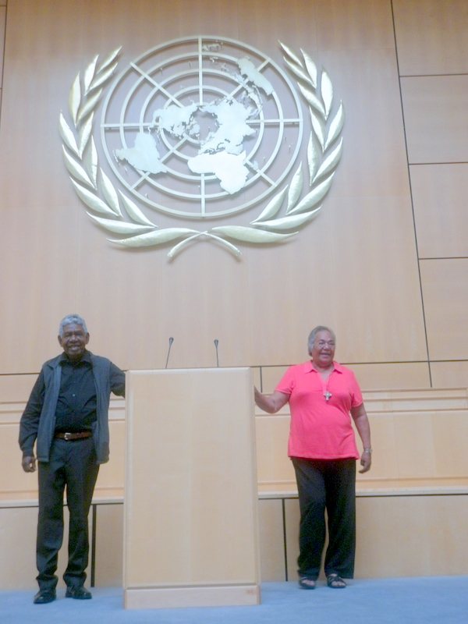
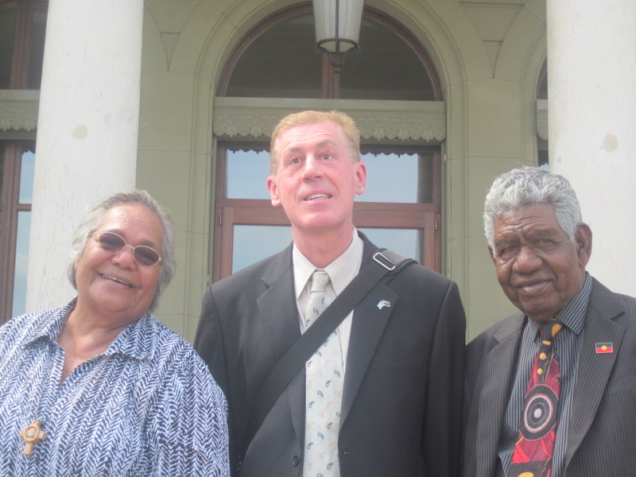
CONTACTS: Rev. Dr. Djiniyini Gondarra OAM 0427 140 232
Rosalie Kunoth-Monks OAM 0419 868 947
Michele Harris OAM 03 9415 7164

