Hornsby Area Residents for Reconciliation invites you to a Free Public Screening of
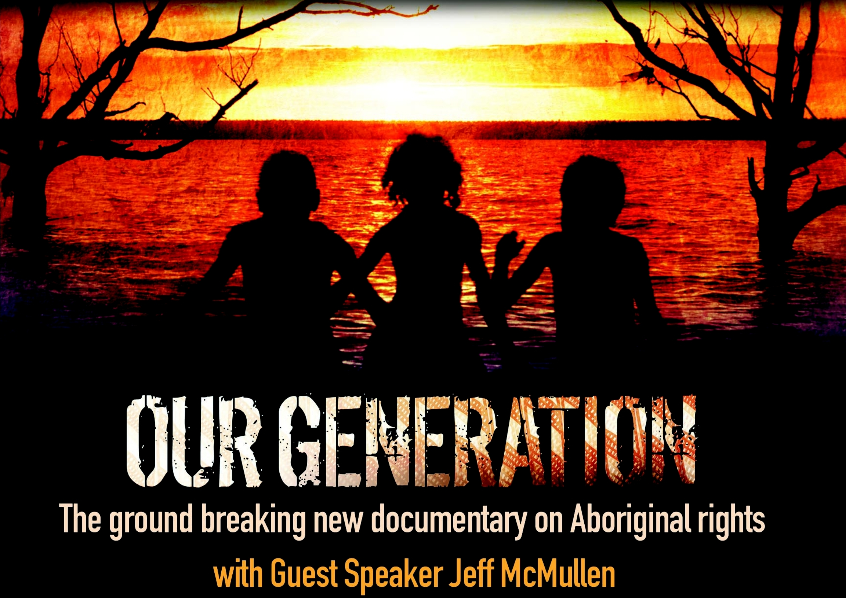
www.ourgeneration.org.au
Introduction and Q&A by

Jeff McMullen AM
Former Foreign Correspondent

The oldest culture on earth is fighting for survival. Our Generation explains the real issues underlying Indigenous disadvantage in this “lucky” country, and the responses of Aboriginal people to the Northern Territory intervention. Through the voices of youth, men, women and elders from remote communities, the film opens the way for dialogue on how Australia can move forward with genuine respect and partnership with its First Peoples.
Date: Monday, 2nd May 2011
Time: 6.30pm for 7.00pm
Venue: Hornsby RSL - Acacia Room
4 High St, Hornsby

FREE EVENT – No bookings required
For enquiries: Dorothy 94822994 or
dbabb@bigpond.net.au

