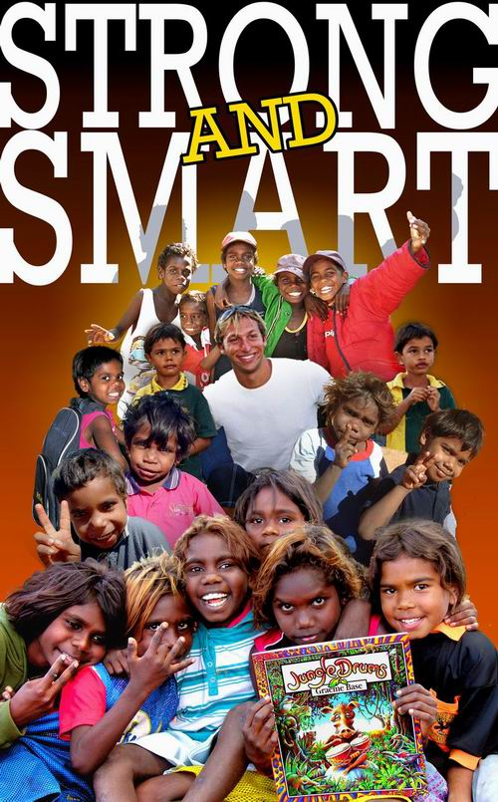

The Literacy Empowerment Project
A Partnership between Aboriginal Australians
and Ian Thorpe’s Fountain for youth

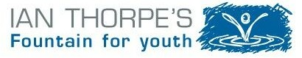

Ian Thorpe’s Fountain for youth is now in the eighth year of a long term project to help improve education and health in remote Indigenous communities. Fountain for youth’s support extends to 21remote communities; 18 located in the Northern Territory; (17 communities to the east and west of Katherine and Maningrida to the east of Darwin on the Arafura Sea), Bidyadanga Community to the south-west of Broome in Western Australia, Palm Island and Lockhart River in the far north of Queensland.

Our work began in 2003 with the funding of maternal and child health education carried out by the award winning Sunrise Health Service Aboriginal Corporation in Katherine. We raised funds from corporate and public donations.

In September 2005 the Federal Government (Coalition), announced a grant of $1million over three years, (2005-2007) to extend the Literacy Empowerment Project. When Kevin Rudd became Prime Minister in November 2007, his Government (ALP) boosted support further with a grant of $1million, 2009-2011. We continue to reach more Aboriginal students each year.

In 2008, Fountain for youth formed a partnership with AIME (Australian Indigenous Mentoring Experience). AIME provides a six-year Mentoring Program for Indigenous high school students from Year 7 through to Year 12. Ian and the Board of Directors are convinced that AIME’S support of many hundreds of Aboriginal high school students each year is one of the best ways we can create stepping stones to higher education, better health and employment, and ultimately equality for all young Australians.

The key components of the Literacy Empowerment Project:

1. Early Learning for Infants & Preschoolers
2. Literacy backpacks for Aboriginal children & families
3. Training children for annual Cultural festival
4. Community Storytelling/Digital Storytelling
5. Ghunmarn Art & Cultural Education Centre (Red Barn)

Community Health & Education Programs:

6. AIME - Australian Indigenous Mentoring Experience
7. Lockhart River Community Projects
8. Yarrabah “Books for Babies” Project

Community Youth Projects:

9. Outback Meets the Beach
10. Flippa Ball in the Pilbara

1. Early Learning for Infants & Preschoolers

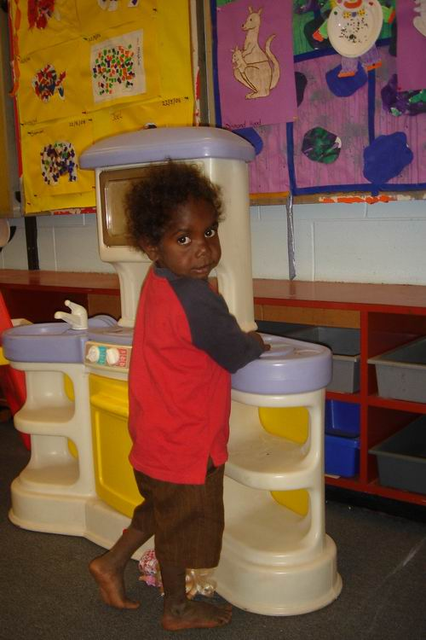
Aboriginal families are the first carers and teachers for their children. Our Early Learning Project helps train and equip families to introduce infants to the crucial first stages of learning and creative play.
In the Jawoyn region to the east of Katherine, NT, Fountain for youth funds an Early Learning Coordinator and Indigenous Teacher working for the Sunrise Health Service Aboriginal Corporation. Aboriginal parents are trained and funded to assist in this vital preschool education.
At La Grange Remote Community School in Bidyadanga, WA, we fund an Early Learning Teacher and Assistant Teacher.
At Lockhart River, on Cape York, QLD, we are supporting young mothers trained to supervise infants and prepare them for school.
The Literacy Empowerment Project is helping Aboriginal infants (0-5’s) make a stronger start. Fountain for youth provides books, early learning toys, cots and other essential equipment to support the introduction of a preschool education for these Australian children and their mums.

Aboriginal Education Workers as support for infants and classroom aides are worth their weight in gold and should be included in the new national effort to improve education for all Australian children.
___________________________________________________________________

2. Literacy Backpacks for Aboriginal Children & Families

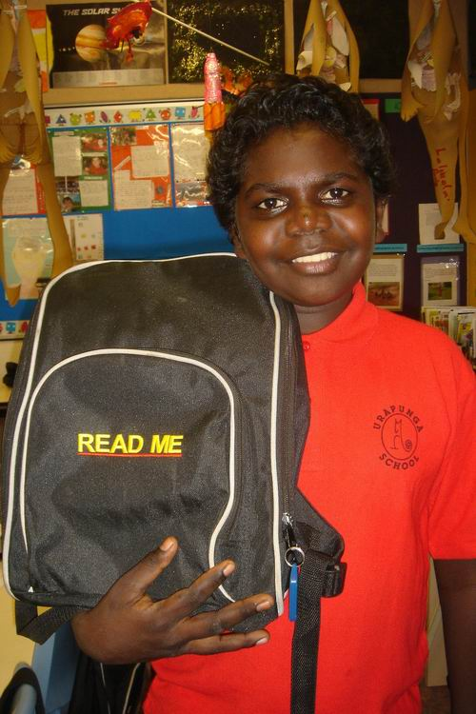
Fountain for youth, with the support of Northern Territory, Western Australia and Queensland schools and teachers, introduces Literacy Backpacks to promote reading by Aboriginal children and their families.

With the support of Federal Education funding, as well as corporate and public donations, we are delivering Literacy backpacks to school children and their families in 17 communities to the east and west of Katherine, Maningrida to the far north of the Northern Territory, Bidyadanga in Western Australia, Lockhart River in far north Queensland and Palm Island Qld.

Literacy Backpacks are now reaching over 2,500 Aboriginal children and their families in 21 remote communities.

Inspired by the Navajo Backpacks that we have seen contribute to improvements in literacy among American First Nations, Ian Thorpe’s Fountain for youth has worked hard since 2003 to build a new alliance committed to tackling the 93% illiteracy in the remote communities of south-eastern Arnhem Land.

Surveys carried out established that most of these remote communities had virtually bookless homes, no public libraries or shops selling reading material. School attendance and parental
interest in reading was well below national averages. In some communities, learning was viewed as “a gubba thing” or of little benefit to children unless you were white.

Students make regular selections of books from an enriched school library. They also take home in their Backpacks early readers for younger brothers and sisters and newspapers and magazines for older members of the family.

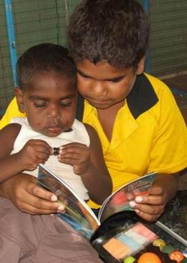
Although reading levels are very low in these remote communities one of the biggest surprises for teachers was seeing the enthusiasm of parents for women’s magazines, Aboriginal newspapers including the Koori Mail and National Indigenous Times and sporting magazines. Reading material has rarely been available in community Stores and it has greatly benefited students to see their parents reading.

The Katherine Group Schools Principal reports that the Literacy Backpack Project has transformed meagre school libraries into a far more valuable community resource.

We must point out that many Australian efforts to promote reading in Indigenous homes collect second-hand books that are not matched to the reading levels of remote communities.

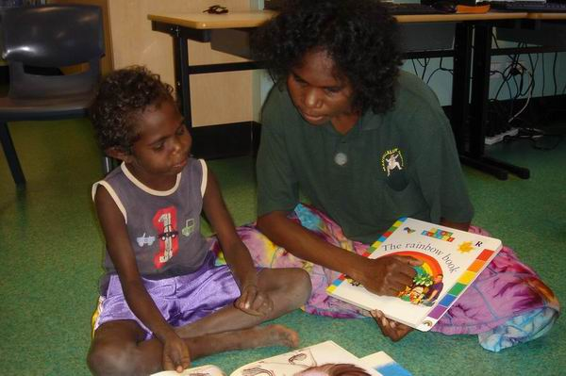

Feedback from Aboriginal students, parents and teachers reinforces research indicating that children who have never had access to good reading material take far greater delight and make more rapid progress when they get to read and ultimately own new books.

Fountain for youth invites members of the public and corporations to sponsor a child’s Literacy Backpack;

$200 can fill a Literacy backpack with suitable books and provide education resources for student, family and the school.

GO TO: www.ianthorpesfountainforyouth.com.au - Online Donations

3. Training Children for Annual Festival

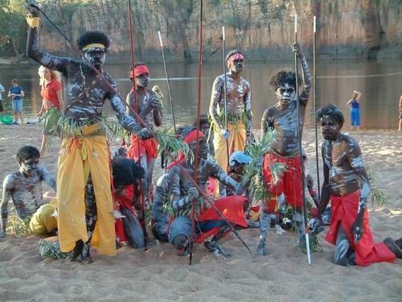
Each year around the end of July, Aboriginal actor, film-maker and musician, Tom Lewis and his community based Djilpin Arts Aboriginal Corporation join elders in leading children and families in a wonderful celebration of traditional Culture.

The “Walking with Spirits” Festival has been staged since 2004 on the shores of the lake Malkgulumbu (Beswick Falls) near Wugularr in the Northern Territory.
The performance at sunset in a spectacular waterfall setting is a fusion of traditional and contemporary dance, song, story-telling and music.

It is a sacred place but on this weekend the Traditional Owners invite visitors to picnic or camp out for the corroboree which can attract dancers and musicians from far off communities. The festival is alcohol free and the tranquillity is a powerful message to children about respect for one another, for Culture and strong family values.
Fountain for youth is supporting the month long training for the young people to develop traditional dance and music, as well as contemporary skills including data projection, animation, audio recordings, digital video production and editing, 3D theatrical objects using fire and puppetry, lighting effects and drama.
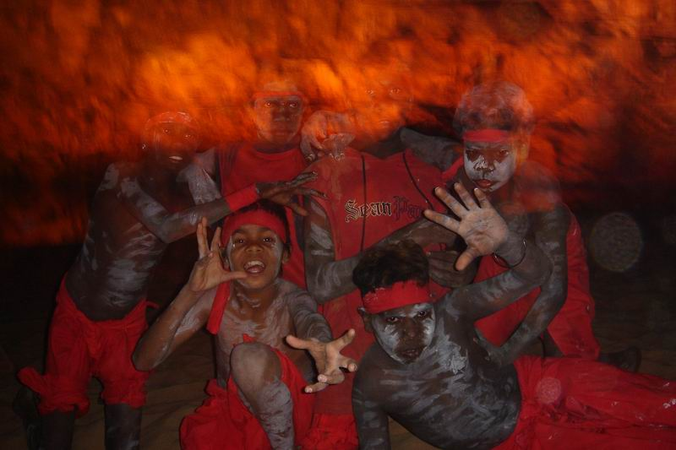
Introducing the children to the many elements of theatre and performance, and working with the Elders to learn traditional stories, songs and dances, encourages the children to write and re-tell these stories in the classroom, valuable support for the work by teachers.

Development of some of these unique and ancient stories has been supported by the ABC and broadcast on the website; www.dustechoes.com

In an area that has battled petrol-sniffing, alcohol abuse and great family stresses the Walking with Spirits Festival is a positive boost to community spirit, considered essential if we are to see gains in education and health for these Aboriginal children.

4. Community Storytelling

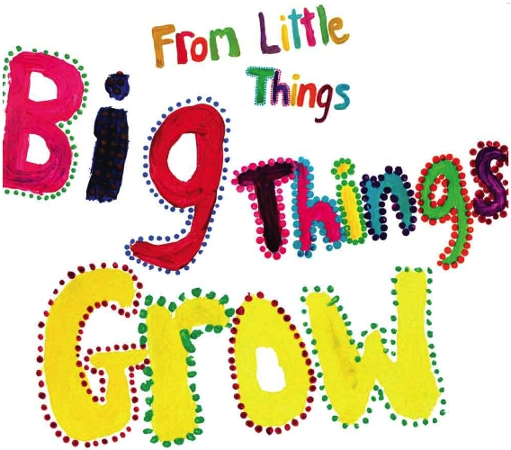
Indigenous knowledge is one of the world's oldest systems of learning and this can add tremendous power and effectiveness to the education of Aboriginal and Torres Strait Islander children.
Jeff McMullen says when Indigenous children discover themselves in a book, see their community in a film or read on a website about the lives of their contemporaries, learning takes on a different meaning.
Ian Thorpe’s Fountain for youth is supporting remote communities to write their own stories and develop digital websites to express who they are and what they know. We fund some of Australia's leading children's authors to work with schools in remote communities and guide Indigenous children as they tell their own stories.
Community Storytelling Books:
Ian Thorpe’s Fountain for youth funded the printing of From Little Things Big Things Grow. Launched in November 2008, this children's book about Vincent Lingiari's struggle for land rights, is a “number one best seller”! Find out more: www.ianthorpesfountainforyouth.com.au

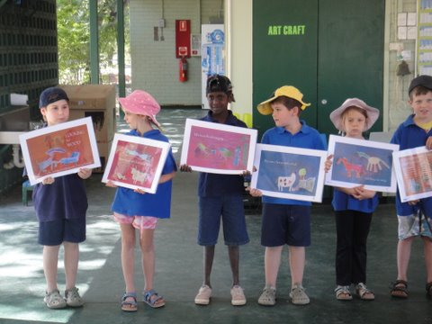
Writing Workshops: Ian Thorpe's Fountain for youth has funded children's writing workshops in Minyerri and Mataranka, NT, by acclaimed author, Alison Lester. Alison encourages the children to write and illustrate their own stories. Many of these have been published and included on the shelves of the school libraries.

Children at Mataranka School sharing one of the stories they wrote and illustrated, “Looking for Wood”

Sharing Our Stories:
Author and illustrator, Liz Thompson has created the ‘Sharing Our Stories’ series, with Elders and children in Wugularr, Jilkminggan & Maningrida NT, Jarlmadangah, Warburton & Purnululu WA. In 2009 work will commence in another eight remote communities for Series 2 of Sharing Our Stories supported by Federal funding and Fountain for youth.
Link to stories>>> http://www.rigby.com.au/indigenous/
Link to the ABC AWAYE, Radio National: http://www.abc.net.au/rn/awaye/stories/2008/2416293.htm
Community ‘Digital Storytelling:
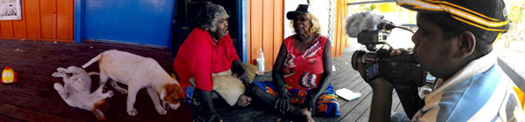
Fountain for youth is supporting the Digital Storytelling Project, led by author, Liz Thompson, as Aboriginal students develop blogs in Wugularr, Jilkminggan and Bidyadanga.
Over a two week period students learn how to storyboard, create written stories, clips, audio recordings and digital images. The communities are connected via the internet and other people from afar can exchange comments and stories. This work will continue in 2010.
View the work of the students, visit: www.sharingstories.com.au
__________________________________________________________________________

5. Ghunmarn Art & Cultural Education Centre (Red Barn)

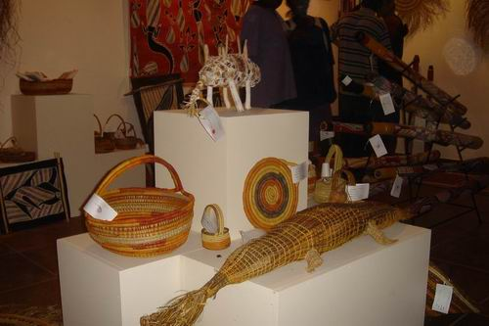
Ian Thorpe's Fountain for youth is supporting the Aboriginal community of Wugularr/Beswick in establishing and developing the Ghunmarn Cultural Centre. Fountain for youth provided $120,000 and Credit Suisse added $36,000 to help the community build its first enterprise.
Ghunmarn, meaning 'altogether', is a local initiative led by Djilpin Arts Aboriginal Corporation under the direction of Tom Lewis and Fleur Parry, to develop the artistic ability of Aboriginal children and showcase the outstanding art from this region.
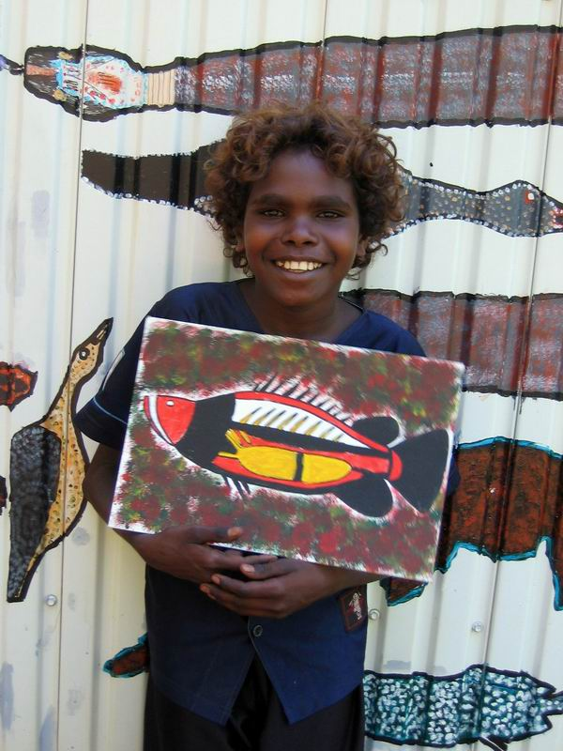
The upper floor of the Centre houses a permanent exhibition, The Blanasi Collection, with paintings by some of Arnhem Land's most significant artists.
A show room on the ground floor displays the outstanding artworks from local artists, providing a point of sale for their works.
This combination of education, exhibition and commerce will help the Centre achieve self-sufficiency.
The Opening of the Ghunmarn Cultural Centre - Monday 21 May 2007
Ian Thorpe and Jeff McMullen were invited by the Traditional Owners to join in a stirring ceremony as they erected the Morning Star pole in front of the Centre.
Victor Hood, spoke of the great pride in seeing the paintings by the old people returned to the community and on show for all to see in the upstairs Gallery.

Artistic Training and Management:
Local women are being trained in management, stocktaking, retail operations, IT, website development and customer service.
The Ghunmarn Cultural Centre is now at the heart of the Wugularr community and a favourite destination for art lovers. Visit the Djilpin Arts website; www.djilpinarts.org.au

6. AIME - AUSTRALIAN INDIGENOUS MENTORING EXPERIENCE

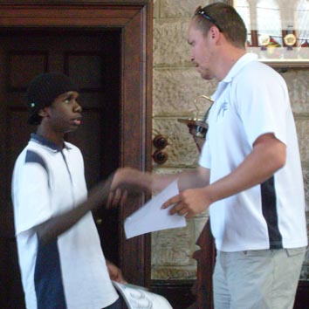
AIME Indigenous Corporation is a not-for-profit charity with DGR status and is established as a national organisation. The CEO and Founder of AIME is Jack Manning Bancroft.

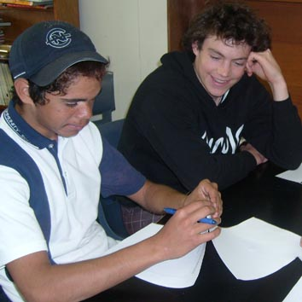
AIME provides access to a six-year Mentoring Program for Indigenous Australian students while undertaking their high school studies from Year 7 through to Year 12. It partners University student volunteers in a one-on-one mentoring relationship with the high school Indigenous students for an hour a week over the course of a 17-week program.
The goals are to improve Year 10 completion rates, Year 12 completion rates and University admission rates for all participating students. The program offers Indigenous high school students over 60 hours of extra one on one support from Year 9 through to Year 12. This has to make a difference. It's a simple model that can be transferred across the nation.
Apart from the impact AIME is having on Indigenous high school students, it offers a significant opportunity for Indigenous and non-Indigenous University students to gain invaluable experience working with Indigenous high school students, and offers a great base for University marketing and recruitment with AIME facilitating the development of long-term partnerships between local high schools and the University.
If the AIME program is given the infrastructure to develop it has the potential to help make huge changes in Indigenous education. With this knowledge the AIME staff, Board, mentors, and supporters work beyond the call of duty, because for all involved in AIME, this is more than work, "it's the right thing to do."
After four years running AIME has been tracking completion rates and indications are that this program is achieving results like no other, AIME works.
Ian Thorpe's Fountain for Youth is proud to be a partner in such an important project and will direct $50,000 per annum to AIME for 2009 - 2011.

Ian and the board of directors of Fountain for Youth are convinced that AIME'S support of many hundreds of Aboriginal high school students each year is one of the best ways we can create stepping stones to higher education, better health and employment, and ultimately equality for all young Australians.
Ian is personally very committed to AIME'S future growth and through his charity hope's he can help develop the national reach of the project.

AIME is looking to partner with Universities and the corporate sector to help expand the program around the country.
Find out more: www.aimementoring.com
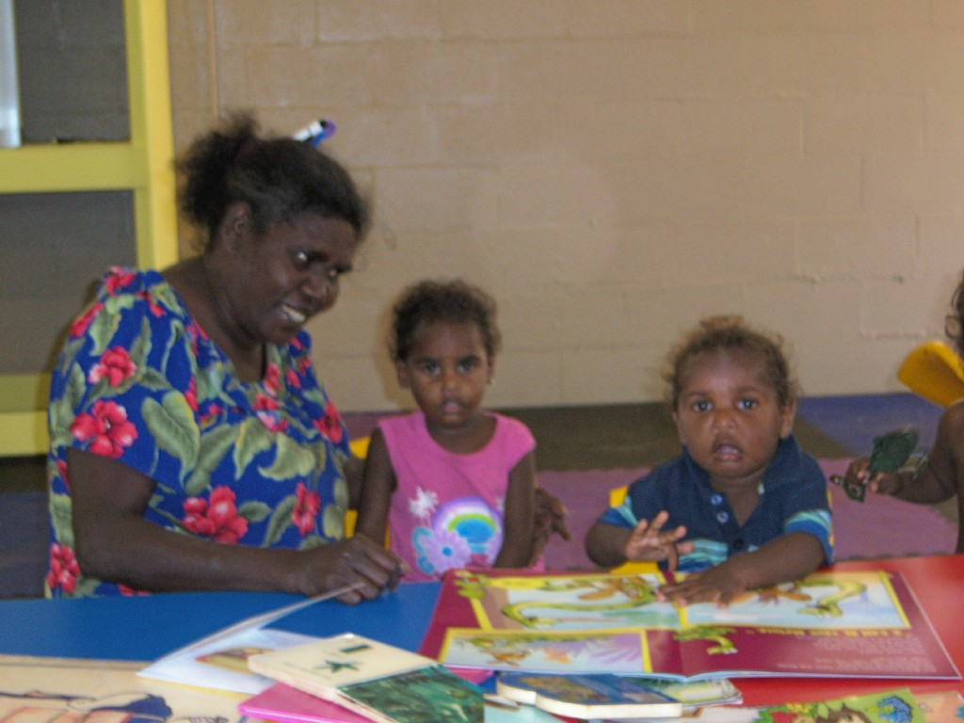

7. Lockhart River Qld Early Learning
Lockhart River is a remote community of about 800 people, 780kms north of Cairns on the eastern side of Queensland's Cape York peninsular.
Since 2007 Ian Thorpe's Fountain for youth has been contributing to the community's efforts to improve early learning and life-skills of several hundred children.
Young parents keen to improve the preschool education of their infants asked Fountain for youth to help provide suitable books, early learning toys, cots and other equipment.
The Lockhart River State School has introduced the Literacy Backpack for about 150 students and their families. Fountain for youth is funding the ongoing supply of books, magazines and newspapers. We are also adding interactive 'smart boards' to the Literacy Program.
A large group of very enterprising young people in Lockhart River are developing eco-tourism projects and other activities for youths who have left school. Ian Thorpe's Fountain for youth is keen to provide the stepping stones to further education and employment opportunities.

8. Yarrabah “Books for Babies” Project

Ian Thorpe’s Fountain for youth and the David Morawetz Social Justice Fund pledged $10,000 to launch "Books for Babies', an Aboriginal health and early learning project at Yarrabah, on the southern point across from Cairns, Queensland.
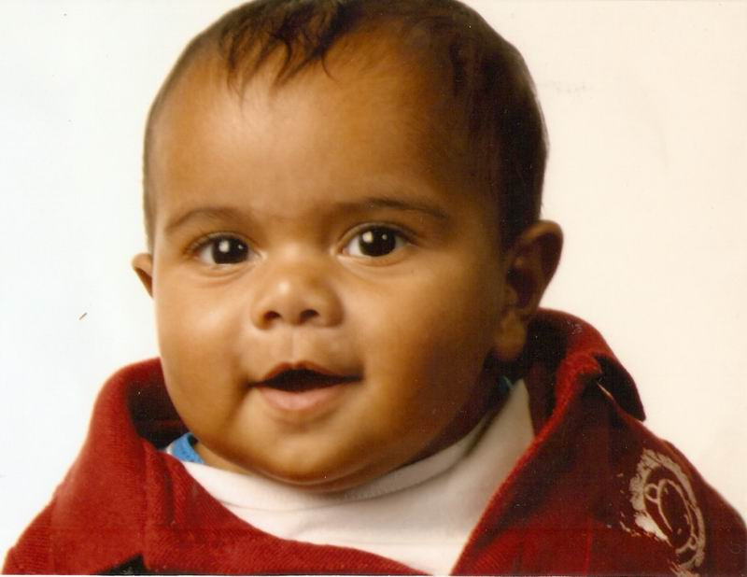
David Morawetz is a Melbourne based Clinical Psychologist and founder of the Morawetz Social Justice Fund, Melbourne Community Foundation. The Yarrabah “Books for Babies” is a highly original project with a strong local community and determined partners. Moy Sweetnam of the Frangipani Dreams organisation has contributed baby clothes, blankets and other items to the project.
Yarrabah State School is progressive in its approach to Indigenous education, winning a national 'Centre for Excellence' award in 2006 and former Principal, Ms Terry Davidson, a ‘High Achiever Principal Award’.
The "Books for Babies” project is led by the teachers of the school in cooperation with the Queensland Health Service and Yarrabah Community Health Service. The project aims to grow parental interest and commitment to early learning by providing a ‘resource pack’ of infant picture books and parental reading material for young parents when they take their new born baby home. On average up to 85 babies are born each year in Yarrabah, a community of 3,500-4000 people.

The resource packs contain baby/parents early learning books, useful information on health and nutrition for the parents along with a locally produced ‘guidance book’ outlining the basic concepts of colour, shapes, sounds, images and explaining the parental role in introducing infants to learning these and other conceptual knowledge.

“Books for Babies” allows literacy empowerment to extend to the infants and children of Yarrabah.
_________________________________________________________________________________

9. Outback Meets the Beach

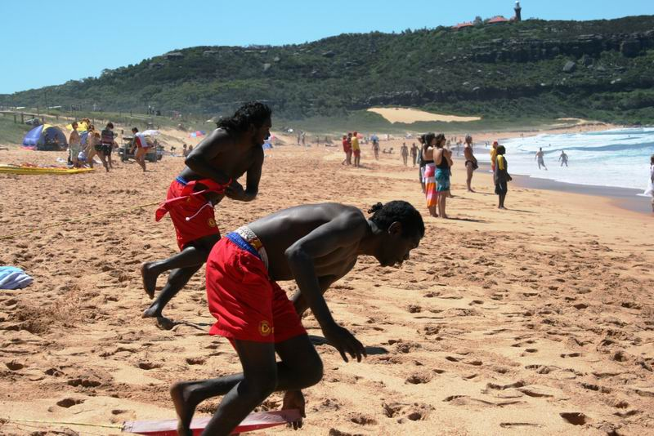
The Annual 'Outback Meets the Beach' began when one of Sydney's most famous surfing communities, North Palm Beach, joined with Ian Thorpe's Fountain for youth to provide the inaugural life-skills training program which ran from February 13th - 27th, 2008.
The North Palm Beach Surf Club hosted a dozen young Aboriginal people (six males and six females aged 15-19) selected by the Jawoyn Association from Wugularr, Barunga and Manyallaluk/Eva Valley in the Northern Territory.

They were supervised by the Surf Club and three Aboriginal Traditional Owners accompanying the young people. Most had never been out of their local region. This was also a great opportunity for Sydney youth to meet and learn from Indigenous Australians. Visits are planned to the Northern Territory communities.
"Outback Meets the Beach", now an annual program, focuses on developing skills, confidence and physical fitness through supervised exercise and water safety.
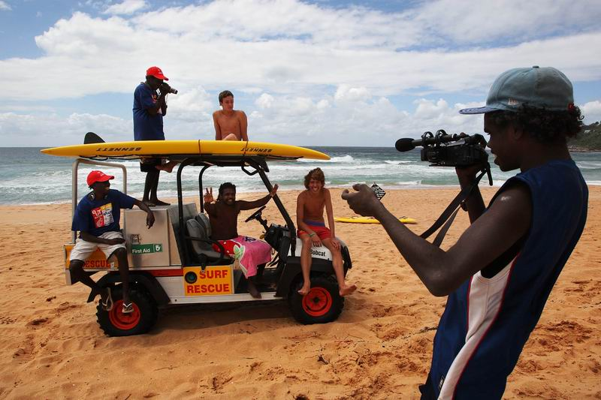
The young people are taught emergency first aid. A Pittwater marina provides training in the operation and maintenance of small boats. This can assist the youth to get work in tourism enterprises back home on the waterways of Nitmiluk Gorge. While in Sydney Indigenous National Park Rangers discussed with the group how to share Cultural knowledge and bush lore in eco-tourism.
Individuals with particular skills were given further opportunity for training and networking with leading professionals who may further their employment prospects.
Young women working in the Ghunmarn Cultural Centre were given instruction by a Newport Art Gallery on marketing and developing new products.
Two young film makers were mentored by several of Australia's leading cinematographers. Among the highlights of the fortnight's training program were the motivational visits by Ian Thorpe, Sydney Swans AFL football stars, Adam Goodes and Michael O'Loughlin, as well as the boxing Kelly brothers. All spoke about healthy living, overcoming setbacks and taking pride in Culture.

The program is a two way learning and exchange of culture, the young members of the surf club made their first trip to Jawoyn country in 2009, walking the Jawoyn country, learning and understanding the importance of culture and connection to land. Outback Meets the Beach continues into 2010, with the link between Jawoyn country and Palm Beach developing strong partnerships and lasting friendships.
Ian Thorpe's Fountain for youth provides funding for this life-skills training program. North Palm Beach Surf Club, ComfortDelGro/CabCharge Company and other corporations contribute generously.

10. FLIPPA BALL IN THE PILBARA
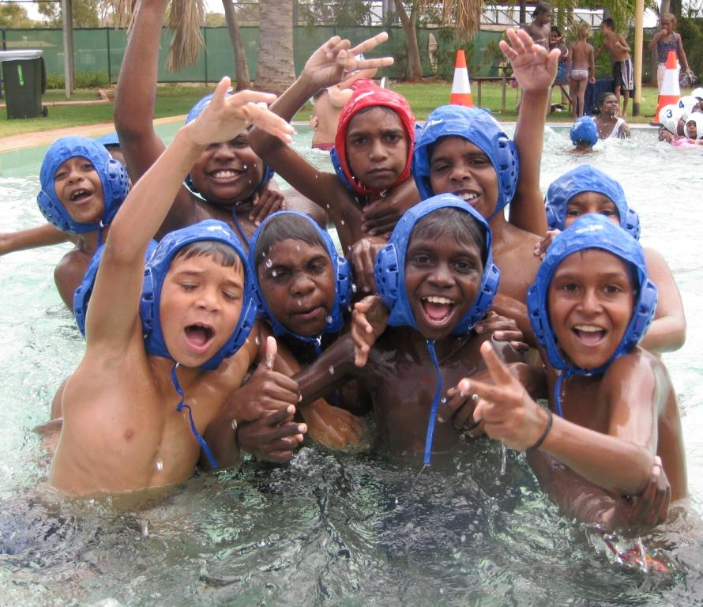
If you were to ask a child in the remote community of Roebourne in Western Australia a year ago what Water Polo was, you would have received a ‘blank stare’!
Ask one of the 30 kids that have been playing at the Roebourne Aquatic Centre and they will now tell you Flippa Ball is, “a game that’s a mix between basketball and soccer but in the water”.
The Melville Water Polo Club (MWPC) has developed a partnership with Ian Thorpe’s Fountain for youth to develop ‘Flippa Ball in the Pilbara’ beginning in the communities of Karratha, Wickham and Roebourne, Western Australia.
Flippa Ball is a non-contact version of water polo for children. It raises awareness and participation in sport whilst contributing to community development and addressing health needs within the remote communities.
The program was initially started with a small competition in Karratha, a remote community 1,700kms from Perth. With such success it was only natural to take this game, which fits so perfectly with the hot climate of the north-west, to the two other communities close by. There are now 75 kids playing ‘Flippa Ball’ in Karratha, 55 kids in Wickham and 30 kids in Roebourne. Due to the popularity of the game two adult ‘water polo’ competitions have been established.
MWPC is lending its top staff to the Pilbara communities not only to coach the kids but also to mentor the parents and volunteers so that they will be able to sustain the program themselves.
‘Flippa Ball’ endeavours to engage youth in structured activities after school hours and on weekends. Organised sport is something that can be taken for granted by people living in the city but in remote communities around Australia there is often no opportunity for structured physical activity, no youth programs nor recreational facilities available. This leaves youth with little to do and as a result often there is a high rate of anti-social behaviour. For many of the Pilbara kids, Flippa Ball is the only regular sport run during the summer months in the communities.
To have fun and engage in an activity such as Flippa Ball will assist in creating routine and stability, build on fitness, ball skills, water confidence, the value of working within a team and the importance of following directions.
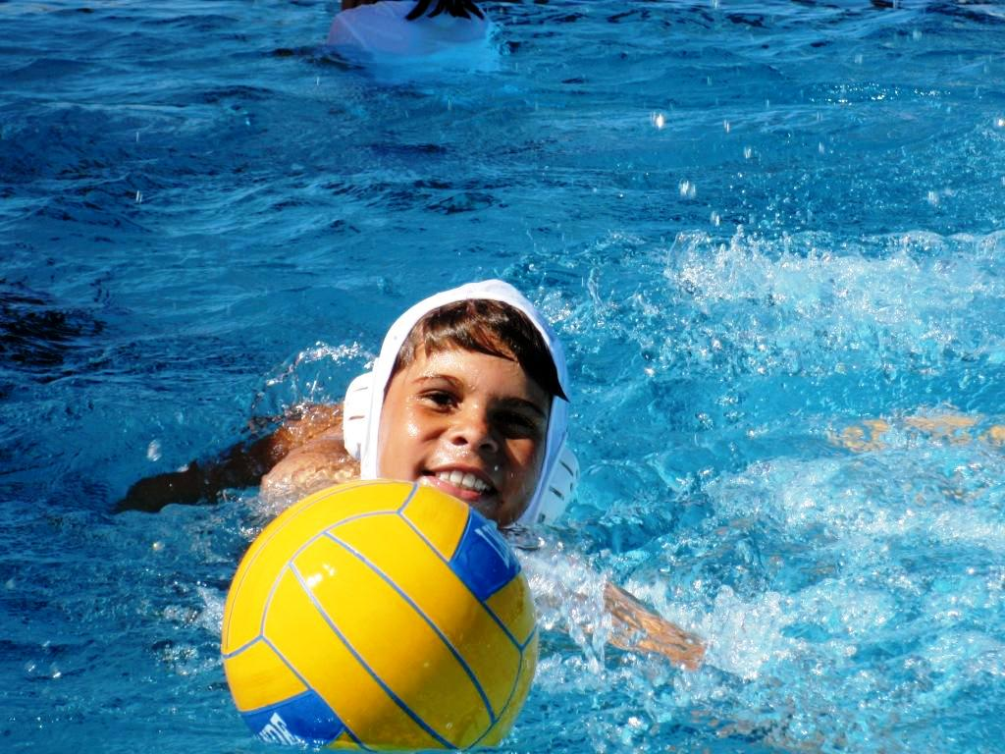
MWPC aims to set up and support healthy, sustainable local water polo competitions, forming a life-long attachment to the game that can only contribute to improved health and fitness, promoting healthy lifestyle choices and strengthening community relationships.
Providing coaching and mentoring by staff and athletes as role models from the highest level, MWPC will develop water polo within the communities for the next three years developing inter-community competition and also an opportunity for the participants for talent identification, development of partnerships between community and the national league teams in Fremantle and Mariners/Marlins, creating opportunities for the children to compete outside their region.
In the years to come we may see some of these kids from the Pilbara playing Water Polo for their country!
It is through the partnership with the Melville Water Polo Club and Ian Thorpe’s Fountain for Youth that we are able to give these kids the opportunity’s they deserve.

For more information on the Fountain for youth projects and ‘articles of interest, visit our website at: www.ianthorpesfountainforyouth.com.au

Ian Thorpe’s Fountain for youth Contacts:

Jeff McMullen CEO, Ian Thorpe’s Fountain for youth
Phone: 02 9974 3533 (O)
Address: PO Box 402
Manly NSW 1655
Email: jeffmcmullen@bigpond.com

Michelle Flaskas Manager, Ian Thorpe’s Fountain for youth
Phone: 02 9949 1356
Fax: 02 8214 3426
Address: Ian Thorpe’s Fountain for youth
PO Box 402, Manly NSW 1655
Email: michelle@fountainforyouth.com.au

