Working Group for Aboriginal Rights and Concerned Australians
Invite you to the LAUNCH of the book

“This Is What We Said”

- a book that details what many Aboriginal people affected by the Intervention really want.

Speaker: Christine Fejo-King
Chair of the National Coalition of Aboriginal and Torres Strait Islander
Social Workers Association and a Larrakia woman

At: Co-op Bookshop
Building 17, Union Court
Australian National University.

On: Thursday 11 February 2010 at 5:30pm

This book is the outcome of a report called
“Will They Be Heard?”
launched last November by the Hon. Malcolm Fraser.

The photography is by Canberran documentary maker Eleanor Gilbert
of Enlightning Productions.

Project supported by the Ron Gray Human Rights Foundation

R.S.V.P. Co-op Bookshop
anu@coop-bookshop.com.au or (02) 6249 6244
by Tuesday 9 February

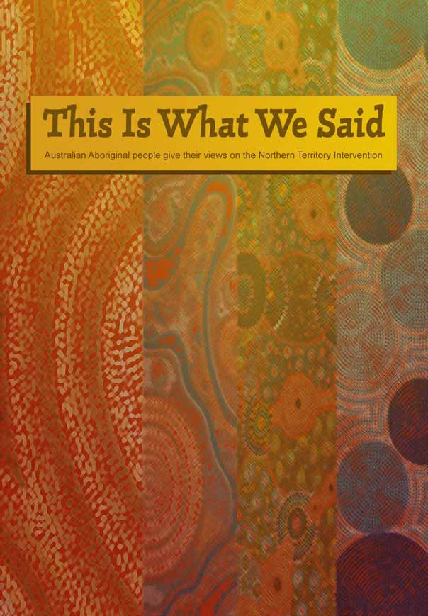
“This Is What We Said” will be launched in February 2010. Using pictures and quotations taken from footage of actual consultations at Bagot, Ampilatwatja, Utopia and Yirrkala, this book provides a graphic account of the depth of frustration and despair of many Aboriginal people in the Northern Territory regarding the Intervention. It is therefore tragic that legislation, about to be debated in Parliament, pays scant attention to the views expressed by many Aboriginal people during the consultations process of 2009. Also included in “This Is What We Said” are quotes on the Intervention from other well known Australians and UN representatives.
The hard covered book can be ordered using the purchase order form that can be accessed via the link on the home page of www.socialpolicyconnections.com.au . It is available at A$15 plus $2 packaging and postage within Australia, per copy. Packaging and postage is free for orders of 4 or more copies within Australia . Also at this website the complete “Will they be heard?” document can be accessed free of charge. This document was launched in November 2009 by Malcolm Fraser and contains an introduction by Alastair Nicholson, plus the full transcripts of the three community consultations.

Canberra launch, 5:30pm, Thursday 11 February 2010, COOP Bookshop ANU

This Is What We Said”
Australian Aboriginal people give their views on the Northern Territory Intervention
“This Is What We Said” will be launched in February 2010. Using pictures and quotations taken from footage of actual consultations at Bagot, Ampilatwatja, Utopia and Yirrkala, this book provides a graphic account of the depth of frustration and despair of many Aboriginal people in the Northern Territory regarding the Intervention. It is therefore tragic that legislation, about to be debated in Parliament, pays scant attention to the views expressed by many Aboriginal people during the consultations process of 2009. Also included in “This Is What We Said” are quotes on the Intervention from other well known Australians and UN representatives.

The hard back book is available at A$15 + A$2 packaging and post, per copy, within Australia. Packaging & postage is free for orders of 4 or more copies. To purchase, print and fill in the order form below, attach your cheque (made payable to Michele. A. Harris) for the total amount payable and mail to:
Michele Harris, concerned Australians, PO Box 281, East Melbourne, Victoria 8002

For information about purchase outside Australia please contact harrisme@bigpond.com

Purchase Order Form for “This Is What We Said”

Your details (please print)
Name
Organisation (if applicable)
Address Street Suburb
Postcode State
Phone number Email
Price per copy A$15 + A$2 packaging and postage (Packaging & postage is free for orders of 4 or more copies)
Number of copies
Total payment A$ Attach cheque made payable to Michele. A. Harris

