John Cleary ABC Sunday Nights 10pm Sunday13th. February
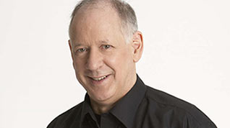John Cleary is a veteran ABC broadcaster and one of Australia's best-known commentators on religion. In his 30-year career with the ABC he has worked extensively in both radio and television, but is known principally for his association with Sunday Nights on ABC Local Radio and The Religion Report on ABC Radio National.
About the Program
Sunday nights is a unique field of religious broadcasting. This four-hour program, broadcast on networked Local Radio across Australia and Radio Australia as well as digital radio and internet streaming, provides highly topical, wide-ranging and interactive coverage of issues of religion, ethics, spirituality, values and social issues.
The program is bracketed by talkback - a topic-based discussion with expert guests in the first hour, and a more general chat about issues of the day in the final hour (the One O'clock Chat Room), with a rotating list of specialist commentators.

Continuation of the Conversation with Elders
Jeff McMullen and Graeme Mundine will be in the Studio with John.
They will be joined by phone (or pre-recording ) by:
Malcolm Fraser
Alastair Nicholson
Rev Dr Djiniyini Gondarra OAM from Galiwin’ku
Djapirri Mununggirritj from Nhulunbuy
Rosalie Kunoth-Monks OAM from Utopia

